**MARKDOWN FILES**

**Headers**

Input:-

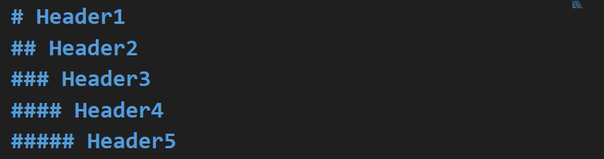

Output:-

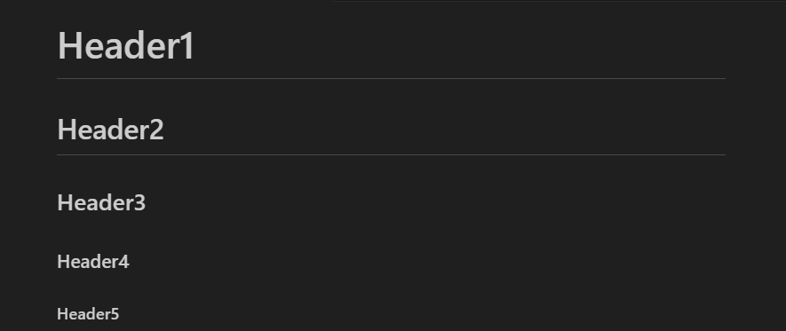

**Paragraphs**

Input:-

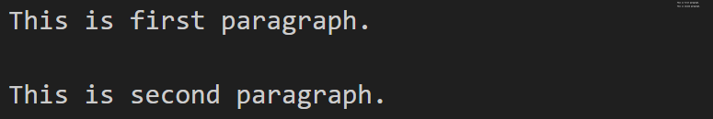

Output:-

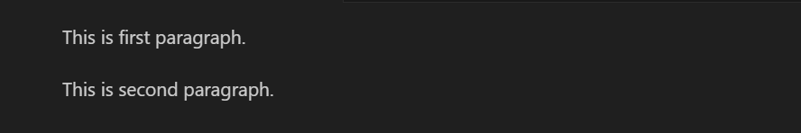

**Emphasis**

Input:-

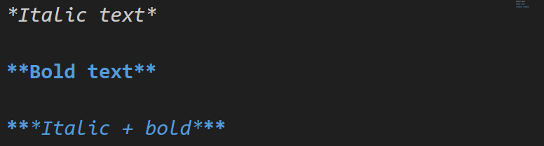

* We can also use underscore (**_**) instead asterick (**\***).

Output:-

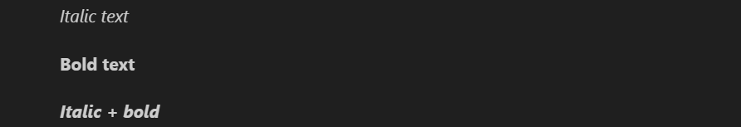

**Line Discrepancies**

Altered previous input:-

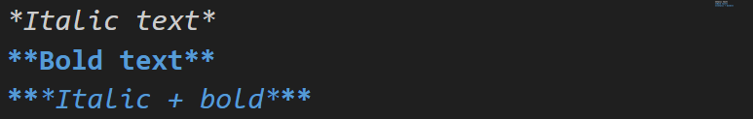

Output:-



**Unordered Lists**

Input:-

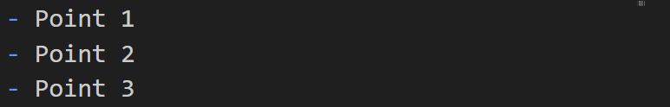

* Can also use **+** or **\*** instead hyphen (**-**).

Output:-



**Ordered Lists**

Input:-

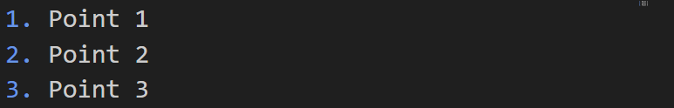

Output:-



**Text Link**



* **Don’t** leave **gap** between **both brackets**, else it will be considered a **normal** **text**.

**Image Link**



**Blockquotes**

Input:-

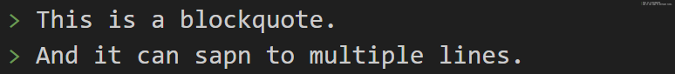

Output:-



**Code**

Input:-

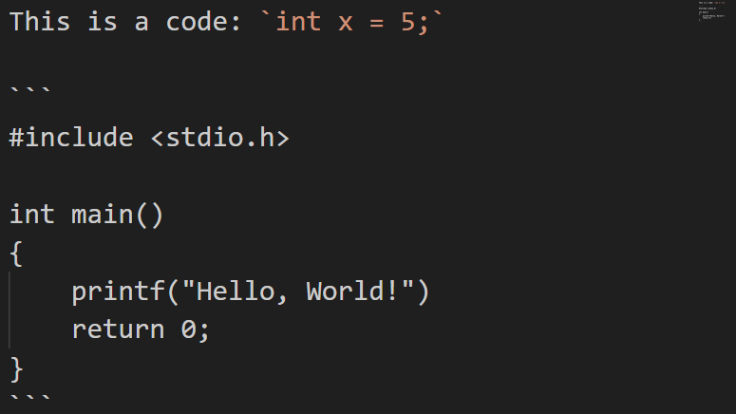

Output:-

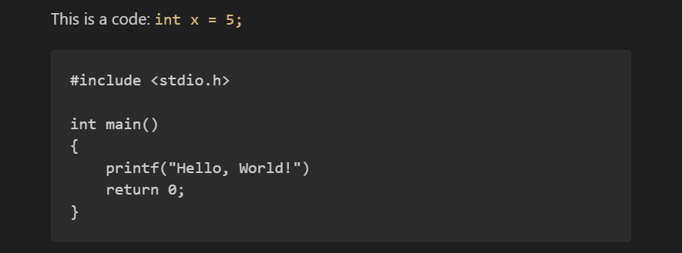

**Horizontal Rule**

Input:-

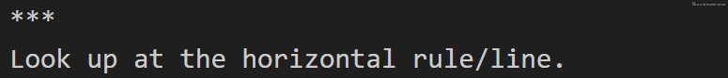

* Can also use triple underscore (**___**) instead asterick (**\*\*\***).

Output:-



**Tables**

Input:-

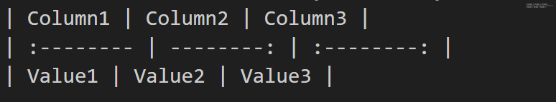

* **Hyphens** tell the **max length** of a column value.
* **:** at first means **left aligned**.
* **:** at last means **right aligned**.
* **:---:** for example, means **centre aligned**.

Output:-

